

**Workforce Solutions Alamo Child Care Services (CCS) Sliding Fee Scale**

**For care authorized October 1, 2024 – January 12, 2025**

Step 1: Find the chart with your family size listed and locate within the row your average monthly income

Step 2: The cost for the first child is listed followed by the cost of each additional child(ren) in care.

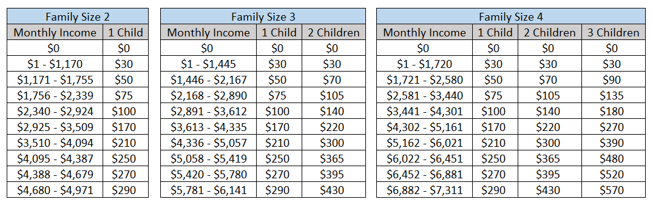

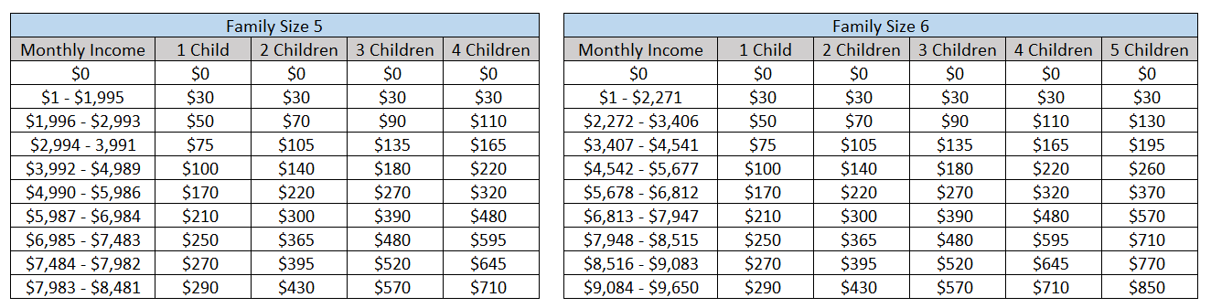

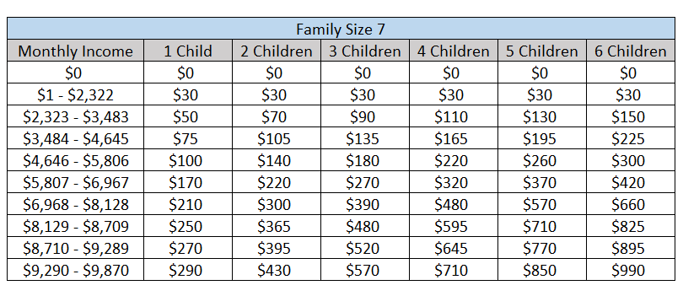

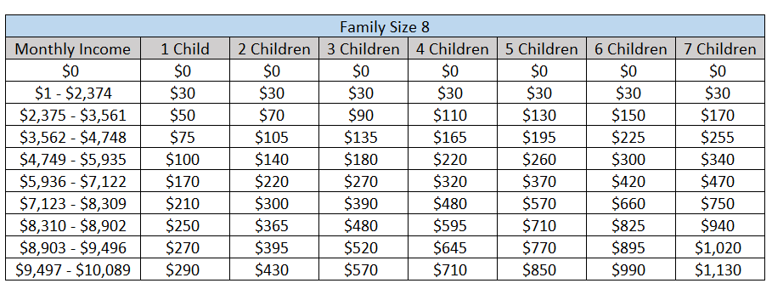

*The parent share of cost cannot exceed the family’s monthly gross income. For larger family sizes, please email [CCS@wsalamo.org](mailto:CCS@wsalamo.org).